#### 

REPORT ON

BATTERY LEVEL INDICATOR WITH LM3914

(Simulation based project)

SUBMITTED BY

Name: S.J. Amith

Reg No.: 12206508

Program Name: Bachelor of technology

(Computer Science & Technology)

UNDER THE GUIDANCE OF

Prof. Suverna Sengar

**School of Computer Science & Engineering**

**Lovely Professional University**

**DECLARATION**

I hereby declare that I have completed my simulation base project on *BATTERY LEVEL INDICATOR WITH LM3914* under the guidance of Prof. Suverna Sengar. I have declared that I have worked with full dedication during the duration of making this project and fulfil the requirements of training for the degree of B.Tech.

Date: 14/11/2022 Signature

Reg no.: 12206508

**ACKNOWLEDGEMENT**

I would like to express my special thanks of gratitude to the Professors, who gave me this golden opportunity to learn a new technology which is used everywhere in our everyday lives.

I would also thank Lovely Professional University for offering me a chance not only for improving my knowledge in core subjects but also providing me with many opportunities in extra curriculum activities.

At last, but not the least, I would thank my parents, friends and classmates for their never-ending support.

**Index**

1. Front page
2. Declaration
3. Acknowledgement
4. Index
5. Components Used
6. Introduction
7. Working
8. Rest of the components
9. Reference

**COMPONENTS USED**

1. LM3914
2. POT-HG
3. RESISTOR
4. GREEN, YELLOW AND RED LED
5. BUTTON
6. CONNECTING WIRES
7. BATTERY

**INTRODUCTION**

As the name indicates, this circuit uses led indicators to indicate the charge level of the battery. It is helpful in knowing the battery percentage in drones, phones and any electrical device.

|  |  |  |
| --- | --- | --- |
| **BATTERY LEVEL** | **PRECENTAGE** | **STATUS OF THE LED** |
| 1.2V | 10 | D1-ON |
| 2.4V | 20 | D1,D2-ON |
| 3.6V | 30 | D1,D2,D3-ON |
| 4.8V | 40 | D1,D2,D3,D4-ON |
| 6.0V | 50 | D1,D2,D3,D4,D5-ON |
| 7.2V | 60 | D1,D2,D3,D4,D5,D6-ON |
| 8.4V | 70 | D1,D2,D3,D4,D5,D6,D7-ON |
| 9.6V | 80 | D1,D2,D3,D4,D5,D6,D7,D8-ON |
| 10.8V | 90 | D1,D2,D3,D4,D5,D6,D7,D8,D9-ON |
| 12.0V | 100 | ALL LEDS-ON |

LM3914:

The LM3914 is a *monolithic integrated circuit* that senses analog voltage levels and drives 10 LEDs, providing a linear analog display. A single pin changes the display from a moving dot to a bar graph. Current drive to the LEDs is regulated and programmable, eliminating the need for resistors.

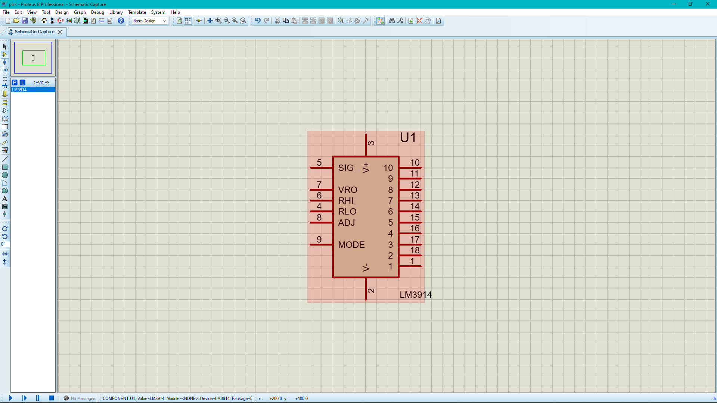

POT-HG:

The variable resistor is a category of resistor that has the ability to change tis resistance measuring capacity. It is an electromechanical device that consists of a slider having resistance components to vary the resistance.

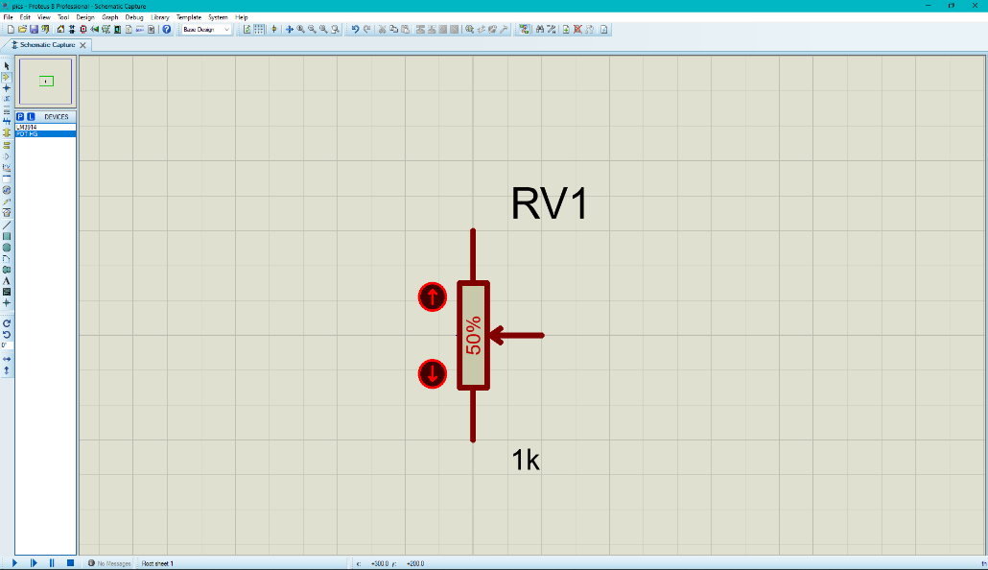

**WORKING**

Step 1: Add a LM3914 and 10 LEDs consisting 4 green LEDs, 4 yellow LEDs and 2 red LEDs.

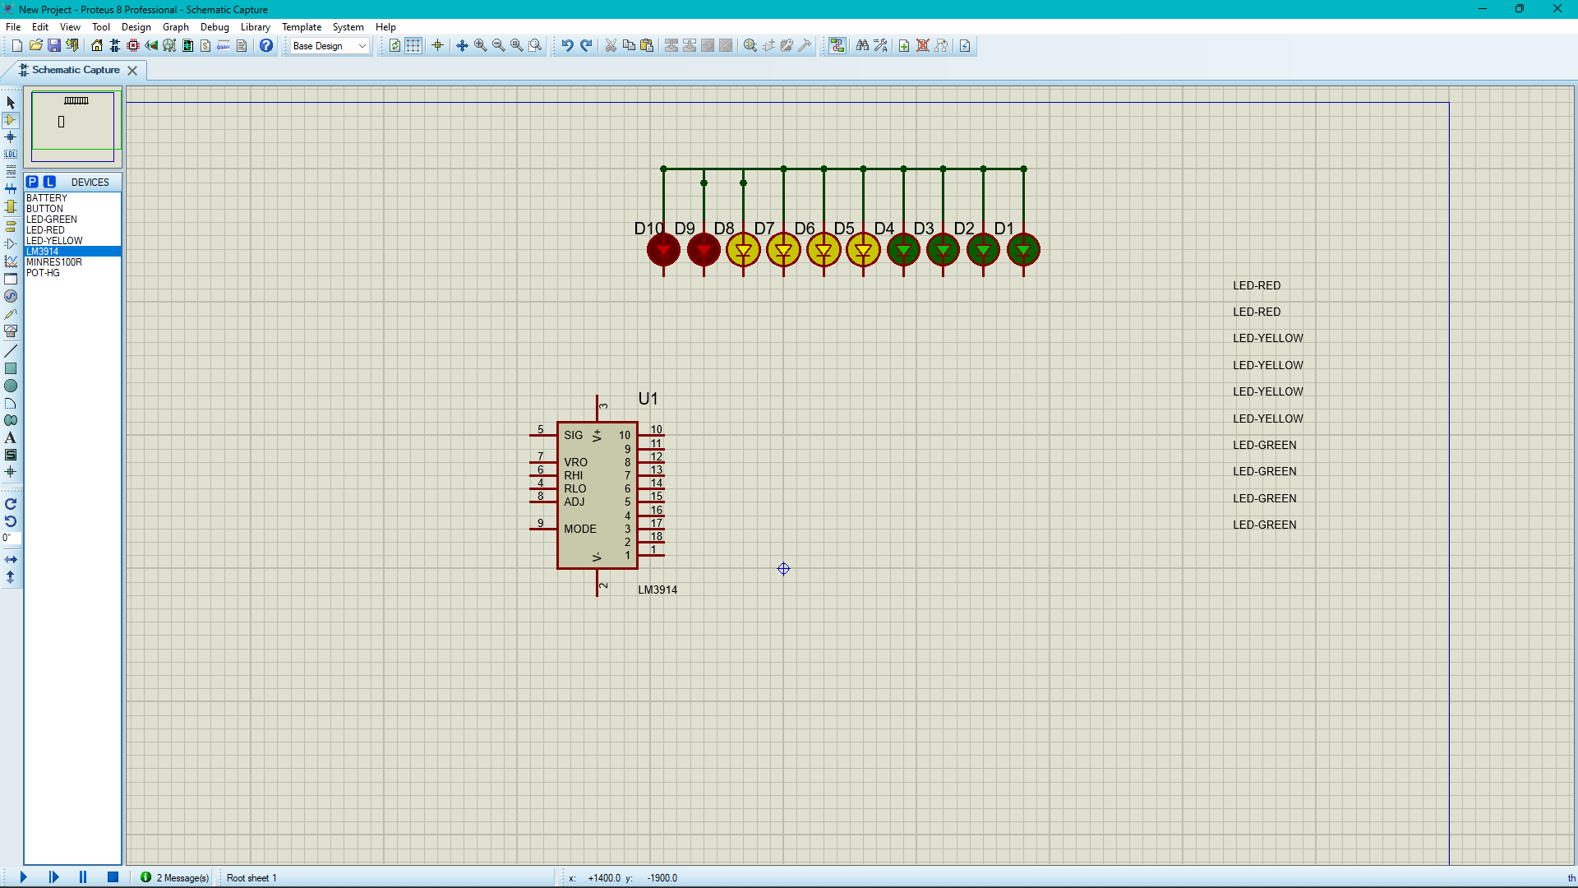

Step 2: Connect the LEDs and LM3914 like shown below.

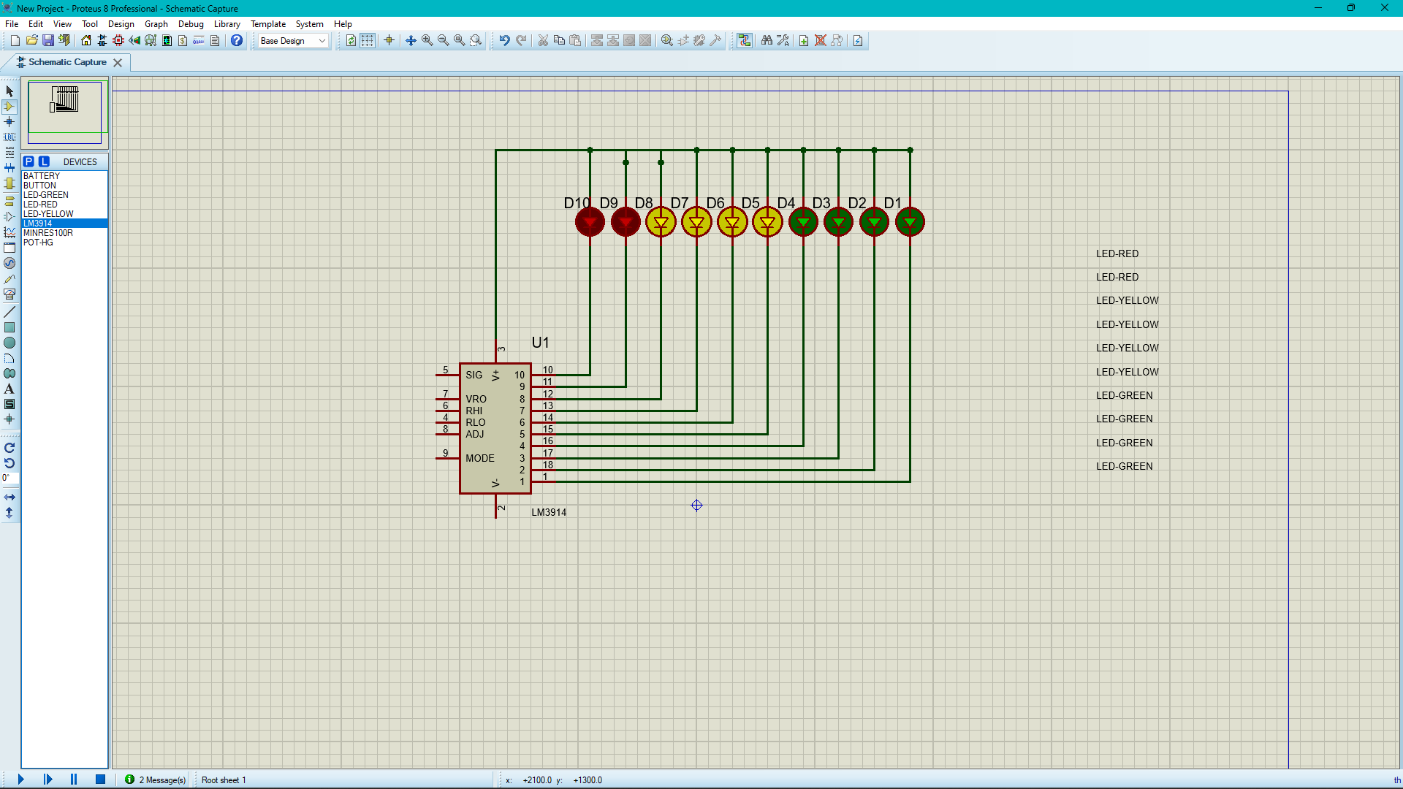

Step 3: Add the rest of the circuit following the given image.

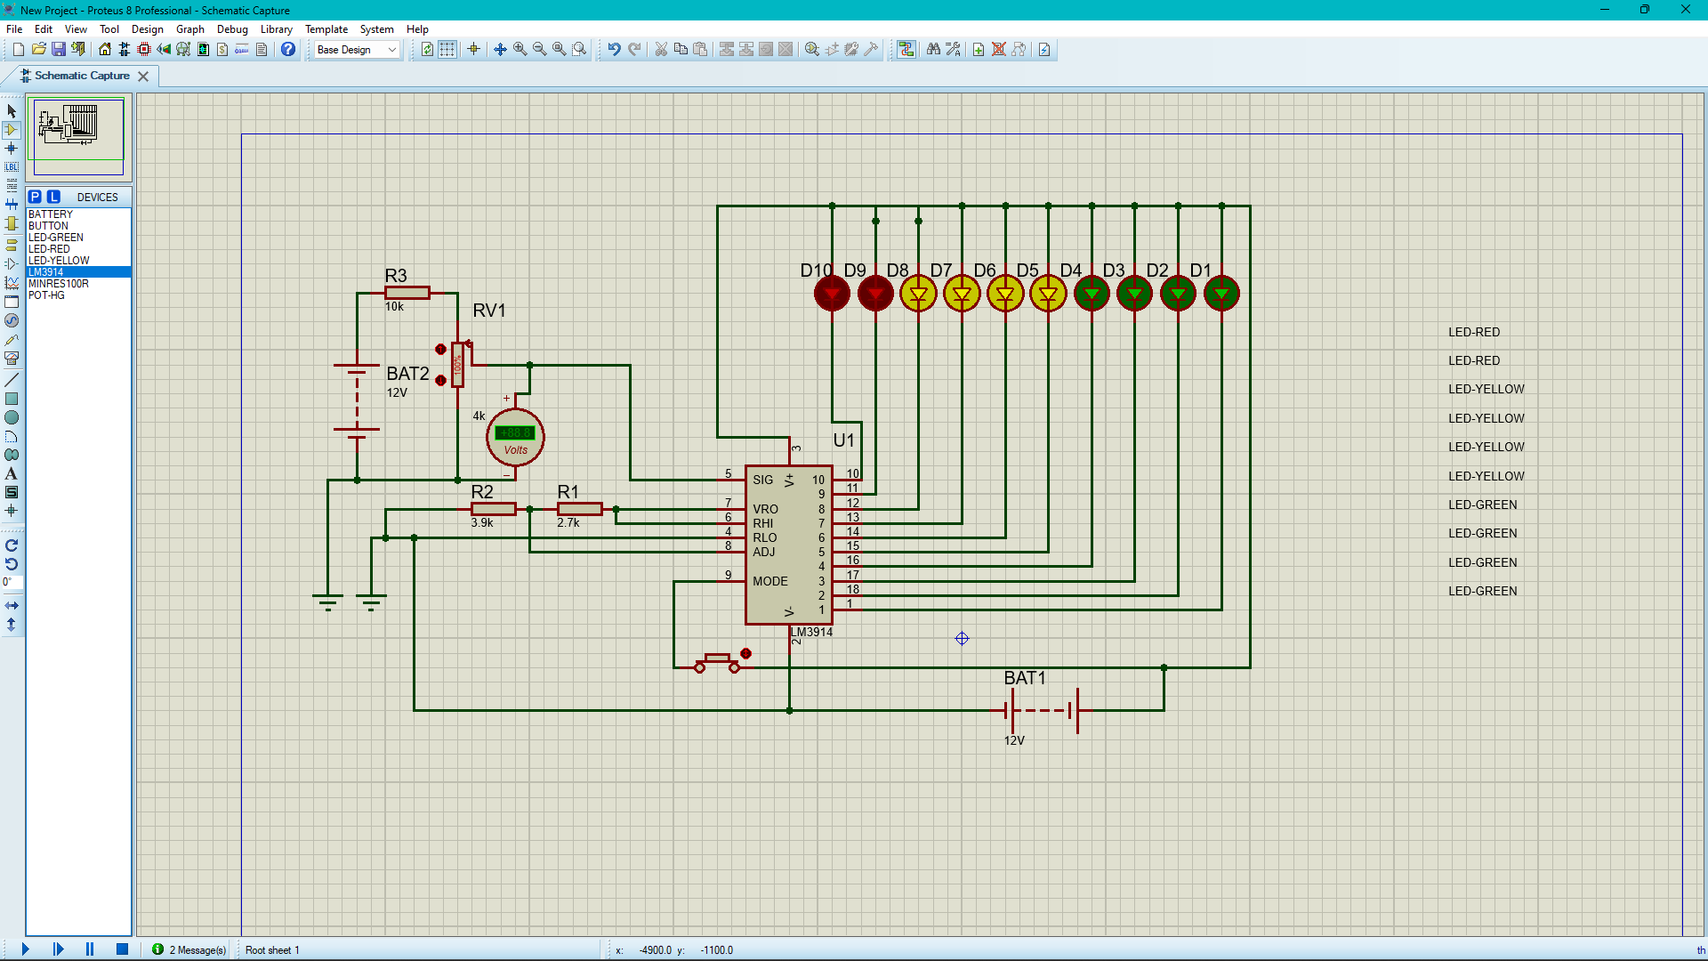

Step 4: Now adjust the POT RV1 so that LED D1 just starts glowing.

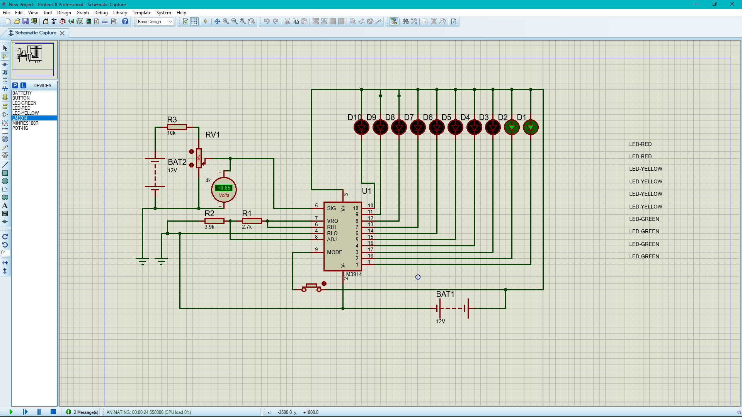

Step 5: Increase the input DC voltage and observe the LEDs.

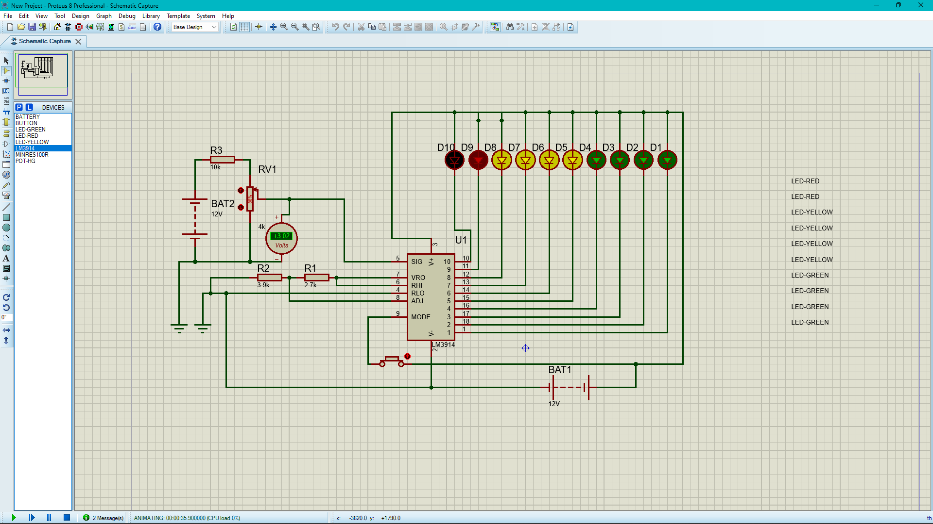

By this we can see that 5 LEDs glow up when there is 50% of the voltage, and all 10 LEDs glow up when there is 100% DC voltage flowing through the circuit. The circuit is designed to monitor 10V to 15V DC. The circuit will even work if the battery voltage is 3V. Even 7-bit display can be connected instead of the 10 LEDs.

**REST OF THE COMPONENETS**

LEDs: A light-emitting diode (LED) is a semiconductor device that emits light when an electric current flows through it. When current passes through an LED, the electrons recombine with holes emitting light in the process. LEDs allow the current to flow in the forward direction and blocks the current in the reverse direction. Light-emitting diodes are heavily doped p-n junctions. Based on the semiconductor material used and the amount of doping, an LED will emit a coloured light at a particular spectral wavelength when forward biased. As shown in the figure, an LED is encapsulated with a transparent cover so that emitted light can come out.

Resistor: A passive electrical component with two terminals that are used for either limiting or regulating the flow of electric current in electrical circuits.

Battery: A battery can be defined as an electrochemical device (consisting of one or more electrochemical cells) which can be charged with an electric current and discharged whenever required. Batteries are usually devices that are made up of multiple electrochemical cells that are connected to external inputs and outputs. Batteries are widely employed in order to power small electric devices such as mobile phones, remotes, and flashlights. Historically, the ‘term’ battery has always been used in order to refer to the combination of two or more electrochemical cells. However, the modern definition of the term ‘battery’ is believed to accommodate devices that only feature a single cell.

**REFERENCE**

* LM3914 by TEXES INSTRUNENTS
* Electrical Technology by A.K.Theraja
* BYJUS.COM
* YOUTUBE.COM
* ELECTRONICSHUB.ORG
* GOOGLE.COM

THANK YOU

-_-

THANK YOU